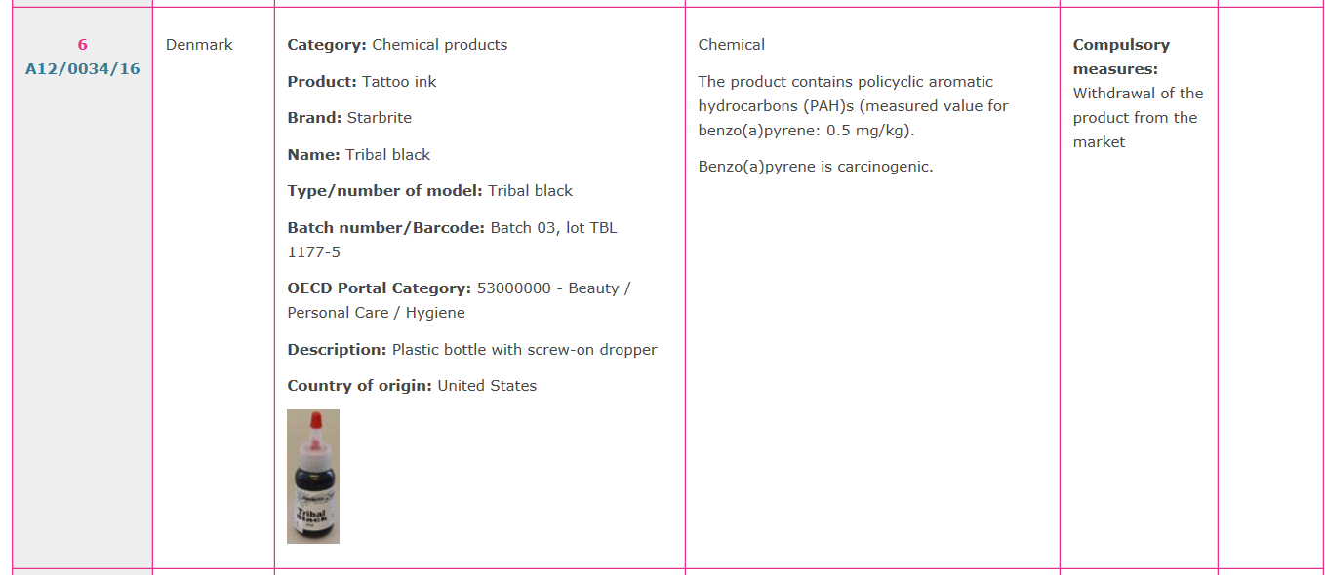
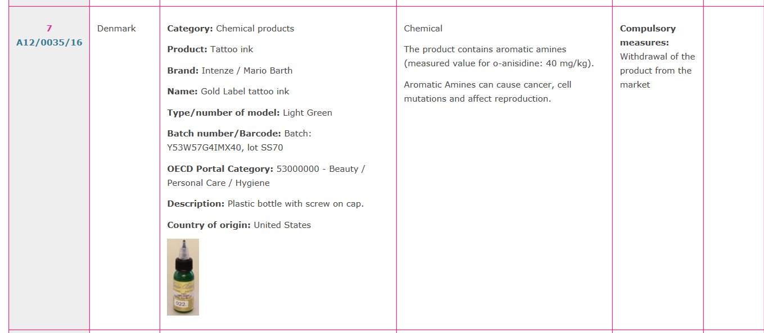
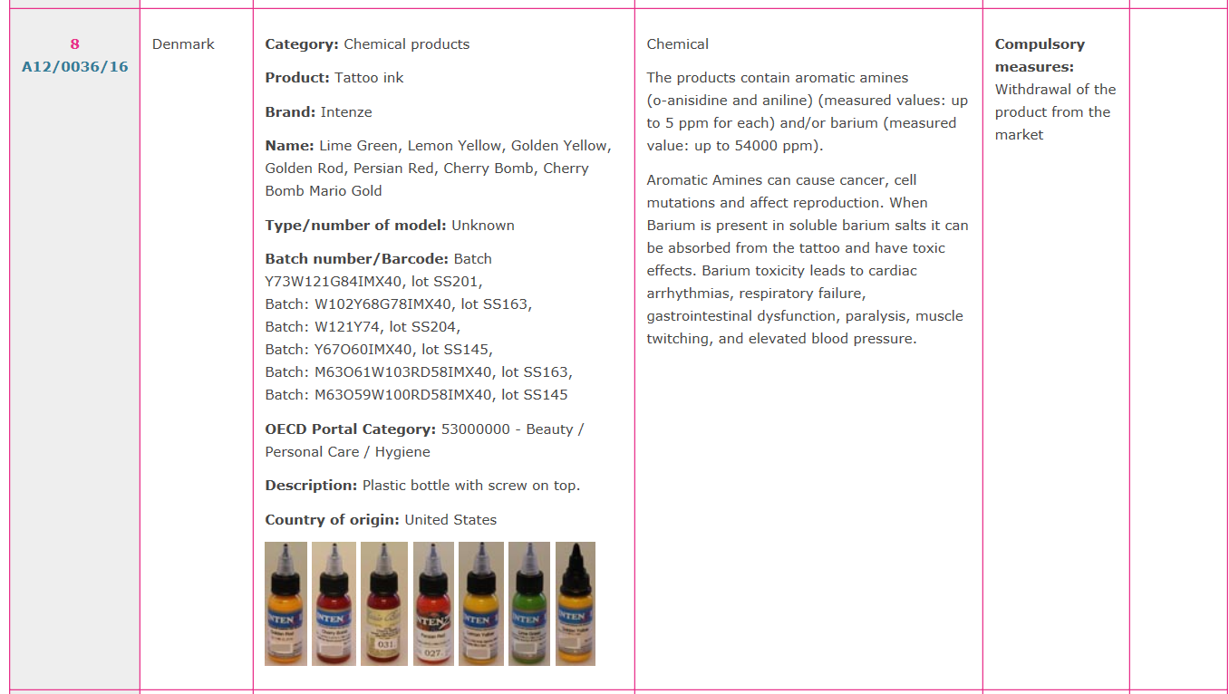
http://ec.europa.eu/consumers/consumers_safety/safety_products/rapex/alerts/main/index.cfm?event=main.weeklyOverview&web_report_id=1721&selectedTabIdx=1

