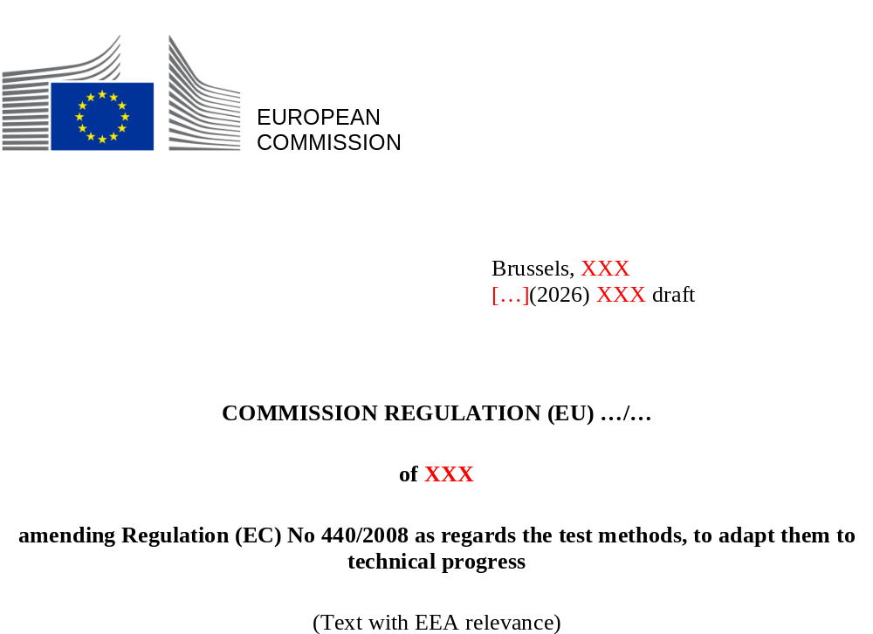

COMMISSION REGULATION (EU) …/…
of XXX
amending Regulation (EC) No 440/2008 as regards the test methods, to adapt them to technical progress
(Text with EEA relevance)
THE EUROPEAN COMMISSION,
Having regard to the Treaty on the Functioning of the European Union,
Having regard to Regulation (EC) No 1907/2006 of the European Parliament and of the Council of 18 December 2006 concerning the Registration, Evaluation, Authorisation and Restriction of Chemicals (REACH), establishing a European Chemicals Agency, amending Directive 1999/45/EC and repealing Council Regulation (EEC) No 793/93 and Commission Regulation (EC) No 1488/94 as well as Council Directive 76/769/EEC and Commission Directives 91/155/EEC, 93/67/EEC, 93/105/EC and 2000/21/EC, and in particular Article 13(2) thereof,
Whereas:
- Commission Regulation (EC) No 440/2008 contains, in its Annex, test methods recognised as being appropriate for generating information on the physicochemical, toxicological and ecotoxicological properties of substances for the purposes of Regulation (EC) No 1907/2006.
- The Organisation for Economic Co-operation and Development (OECD) develops harmonised and internationally agreed test guidelines for the testing of chemicals for regulatory purposes. The OECD regularly issues new and revised test guidelines, taking account of scientific progress in this area.
- In order to adapt Regulation (EC) No 440/2008 to technical progress and to reduce the number of animals used for experimental purposes, also in accordance with Directive 2010/63/EU of the European Parliament and of the Council, the Annex to Regulation (EC) No 440/2008 should be revised by introducing one new and updating four existing test methods for the assessment of ecotoxicity and eighteen updated test methods for the determination of effects on human health. Ten of these eighteen test methods relate to in vitro tests for skin irritation/corrosion, serious eye damage/eye irritation, skin sensitisation, immunotoxicity and endocrine effects. For six of these eighteen test methods the outdated versions of the full descriptions are laid down in Part B (OECD Test Guideline 407, OECD Test Guideline 421, OECD Test Guideline 422) and in Part C (OECD Test Guideline 210, 236, 239) of the Annex to Regulation (EC) No 440/2008. It is therefore appropriate to replace those full descriptions with the links to the latest version of the corresponding OECD Test Guidelines.
- In addition, the OECD has corrected certain test methods, which were included in Regulation (EC) No 440/2008 – (OECD Test Guideline 111, OECD Test Guideline 307, OECD Test Guideline 308, OECD Test Guideline 316, OECD Test Guideline 492, OECD Test Guideline 442C, OECD TG 442E) – in 2025 and 2026. For three out of these seven test methods, the outdated versions of the full descriptions are laid down in Part C (OECD Test Guideline 111, OECD Test Guideline 307, OECD Test Guideline 308) of the Annex to Regulation (EC) No 440/2008. It is therefore appropriate to replace those full descriptions with links to the latest version of the corresponding OECD Test Guidelines.
- Regulation (EC) No 440/2008 should therefore be amended accordingly.
- The relevant stakeholders have been consulted on the proposed amendment.
- The measures provided for in this Regulation are in accordance with the opinion of the Committee established under Article 133(1) of Regulation (EC) No 1907/2006,
HAS ADOPTED THIS REGULATION:
Article 1
The Annex to Regulation (EC) No 440/2008 is amended in accordance with the Annex to this Regulation.
Article 2
This Regulation shall enter into force on the twentieth day following that of its publication in the Official Journal of the European Union.
This Regulation shall be binding in its entirety and directly applicable in all Member States.
Done at Brussels,
For the Commission

The President
Ursula VON DER LEYEN

OJ L 396, 30.12.2006, p. 1, ELI: https://data.europa.eu/eli/reg/2006/1907/oj
Commission Regulation (EC) No 440/2008 of 30 May 2008 laying down test methods pursuant to Regulation (EC) No 1907/2006 of the European Parliament and of the Council on the Registration, Evaluation, Authorisation and Restriction of Chemicals (REACH) (OJ L 142, 31.5.2008, p. 1, ELI: https://data.europa.eu/eli/reg/2008/440/oj).
Directive 2010/63/EU of the European Parliament and of the Council of 22 September 2010 on the protection of animals used for scientific purposes (OJ L 276, 20.10.2010, p. 33, ELI: https://eur-lex.europa.eu/eli/dir/2010/63/oj).
OECD Test Guideline 254: Mason bees (Osmia sp.), Acute Contact Toxicity Test (2025) https://doi.org/10.1787/900175fa-en; OECD Test Guideline 203: Fish, Acute Toxicity Test (2025) https://doi.org/10.1787/9789264069961-en; OECD Test Guideline 210: Fish, Early-life Stage Toxicity Test (2025) https://doi.org/10.1787/9789264203785-en; OECD Test Guideline 236: Fish Embryo Acute Toxicity (FET) Test (2025) https://doi.org/10.1787/9789264203709-en; OECD Test Guideline 239: Water-Sediment Myriophyllum Spicatum Toxicity Test (2025) https://doi.org/10.1787/9789264224155-en.
OECD Test Guideline 407: Repeated Dose 28-day Oral Toxicity Study in Rodents (2025) https://doi.org/10.1787/9789264070684-en; OECD Test Guideline 408: Repeated Dose 90-Day Oral Toxicity Study in Rodents (2025) https://doi.org/10.1787/9789264070707-en; OECD Test Guideline 421: Reproduction/Developmental Toxicity Screening Test (2025) https://doi.org/10.1787/9789264264380-en; OECD Test Guideline 422: Combined Repeated Dose Toxicity Study with the Reproduction/Developmental Toxicity Screening Test (2025) https://doi.org/10.1787/9789264264403-en; OECD Test Guideline 467: Defined Approaches for Serious Eye Damage and Eye Irritation (2025) https://doi.org/10.1787/28fe2841-en; OECD Test Guideline 491: Short Time Exposure In Vitro Test Method for Identifying i) Chemicals Inducing Serious Eye Damage and ii) Chemicals Not Requiring Classification for Eye Irritation or Serious Eye Damage (2025) https://doi.org/10.1787/9789264242432-en; OECD Test Guideline 497: Defined Approaches on Skin Sensitisation (2025) https://doi.org/10.1787/b92879a4-en; OECD Test Guideline 431: In vitro skin corrosion: reconstructed human epidermis (RHE) test method (2025) https://doi.org/10.1787/9789264264618-en; OECD Test Guideline 439: In Vitro Skin Irritation: Reconstructed Human Epidermis Test Method (2025) https://doi.org/10.1787/9789264242845-en; OECD Test Guideline 444A: In Vitro Immunotoxicity: IL-2 Luc and Il-2 Luc LTT Assays (2025) https://doi.org/10.1787/27b10ba3-en; OECD Test Guideline 437: Bovine Corneal Opacity and Permeability Test Method for Identifying i) Chemicals Inducing Serious Eye Damage and ii) Chemicals Not Requiring Classification for Eye Irritation or Serious Eye Damage (2025) https://doi.org/10.1787/9789264203846-en; OECD Test Guideline 442B: Skin Sensitization: Local Lymph Node Assay: BrdU-ELISA or –FCM (2025) https://doi.org/10.1787/9789264090996-en; OECD Test Guideline 443: Extended One-Generation Reproductive Toxicity Study (2025) https://doi.org/10.1787/9789264185371-en; OECD Test Guideline 442C: In Chemico Skin Sensitisation: Assays addressing the Adverse Outcome Pathway key event on covalent binding to proteins (2025) https://doi.org/10.1787/9789264229709-en; OECD Test Guideline 456: H295R Steroidogenesis Assay (2025) https://doi.org/10.1787/9789264122642-en; OECD Test Guideline 470: Mammalian Erythrocyte Pig-a Gene Mutation Assay (2025) https://doi.org/10.1787/4faea90e-en; OECD Test Guideline 488: Transgenic Rodent Somatic and Germ Cell Gene Mutation Assays (2025) https://doi.org/10.1787/9789264203907-en; OECD Test Guideline 442D: In Vitro Skin Sensitisation: Assays addressing the Adverse Outcome Pathway Key Event on Keratinocyte activation (2026) https://doi.org/10.1787/9789264229822-en.
OECD Test Guideline 111: Hydrolysis as a Function of pH (2025) https://doi.org/10.1787/9789264069701-en.
OECD Test Guideline 307: Aerobic and Anaerobic Transformation in Soil (2025) https://doi.org/10.1787/9789264070509-en.
OECD Test Guideline 308: Aerobic and Anaerobic Transformation in Aquatic Sediment Systems (2025) https://doi.org/10.1787/9789264070523-en.
OECD Test Guideline 316: Phototransformation of Chemicals in Water – Direct Photolysis (2025) https://doi.org/10.1787/9789264067585-en.
OECD Test Guideline 492: Reconstructed human Cornea-like Epithelium (RhCE) test method for identifying chemicals not requiring classification and labelling for eye irritation or serious eye damage (2025) https://doi.org/10.1787/9789264242548-en.
OECD Test Guideline 442C: In Chemico Skin Sensitisation: Assays addressing the Adverse Outcome Pathway key event on covalent binding to proteins (2026) https://doi.org/10.1787/9789264229709-en.
OECD Test Guideline 442E: In Vitro Skin Sensitisation: In Vitro Skin Sensitisation assays addressing the Key Event on activation of dendritic cells on the Adverse Outcome Pathway for Skin Sensitisation (2026) https://doi.org/10.1787/9789264264359-en

